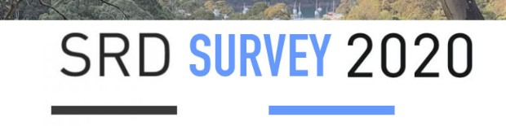
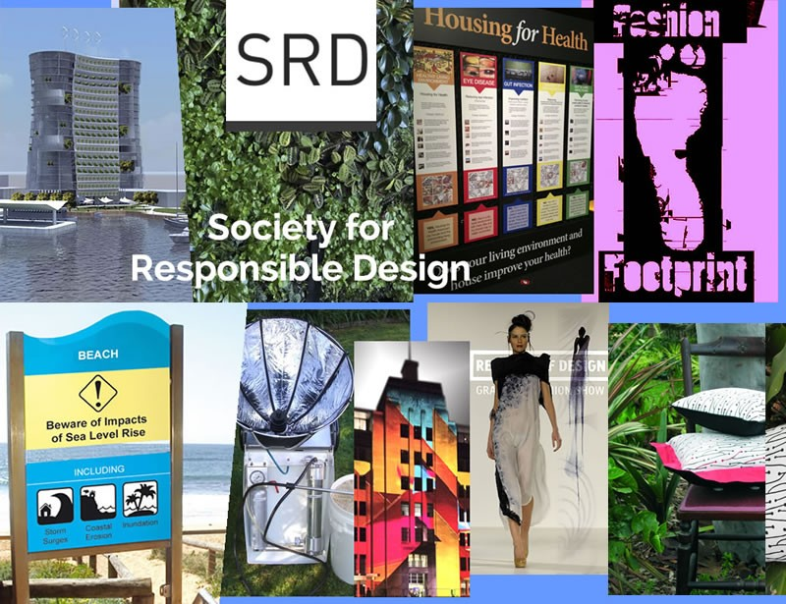
+

This survey is for all SRD Members and friends. You're invited to comment & suggest future directions for the Society for Responsible Design https://srd.org.au

Please add any comments to more clearly elaborate. You may email SRD with longer responses, news stories, feedback or questions srd@srd.org.au
Thank you.

- SRD should Promote and demonstrate Responsible Design as the Apex Design Mode to create our sustainable future.
simple (or max 255 character) answer

rating 1 min to 12 max

- SRD must Develop the concept, process and collation of #ResponsibleDesign across all fields.
simple (or max 255 character) answer

rating 1 min to 12 max

- SRD can Promote greener businesses, organisations, projects, products and individuals via SRD Pro Active Top 25%.
simple (or max 255 character) answer

rating 1 min to 12 max

- SRD should Create an online market for greener practice and products.
simple (or max 255 character) answer

rating 1 min to 12 max

- SRD must better promote: “Advance #ResponsibleDesign thinking globally, act locally, share and repeat."
simple (or max 255 character) answer

rating 1 min to 12 max

- SRD can Develop self-help groups for greener renovations or similar, possibly working with Renew, Permaculture Au, Architects Declare or other groups.

simple (or max 255 character) answer

rating 1 min to 12 max

- SRD should focus on looking for & developing solutions to the world's big issues such as:

simple (or max 255 character) answer

rating 1 min to 12 max

- SRD must focus on methods to accelerate the greener circular economy, grow regenerative design and investing in clean and green super or similar.
simple (or max 255 character) answer

rating 1 min to 12 max

- SRD should grow innovation in SDGs eg further assisting the Young Persons’ Plan for the Planet and its rollout world-wide or other programs.
simple (or max 255 character) answer

rating 1 min to 12 max

- SRD can just continue to develop as it has for 31 years. Any other web or newsletter feedback? Your answers are appreciated and will assist greatly, thank you.

Yes or elaborate and rate

Your Postcode

Your Name (optional)

Thank you for your comments to confirm the value of and suggest future directions for the Society for Responsible Design https://srd.org.au

You are welcome to add any comments to more clearly elaborate. You may email SRD with longer responses, news stories, feedback or questions srd@srd.org.au

